**Javascript notes –Prakash**

* Javascript engine at ur browser , **CHROME –V8**

**mozilla firefox- Spidermonkey**

1. Ways to print in javascript:

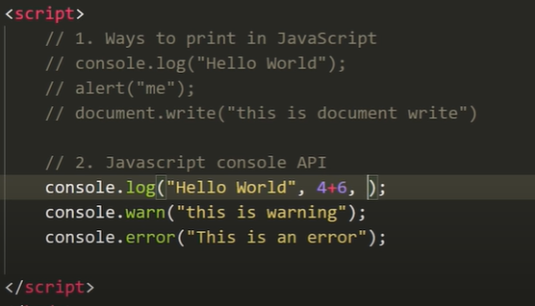

1. Variables in javascript:

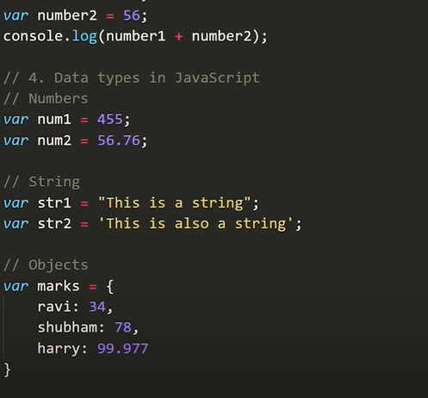

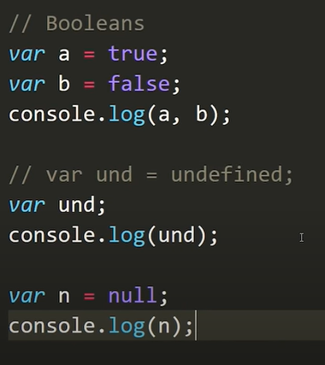

**Undefined** (no value assigned)

**Null** (user don’t want any value their)

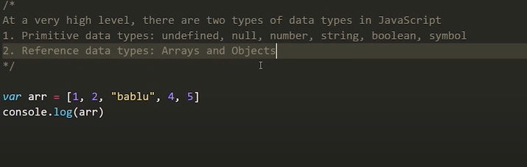

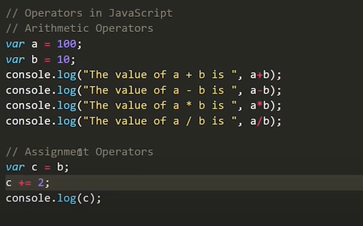

**Functions in JavaScript’s:**

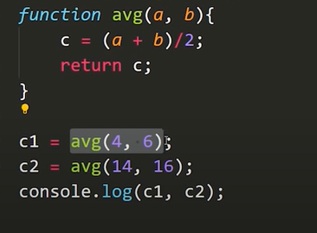

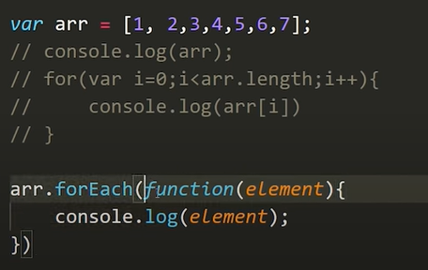

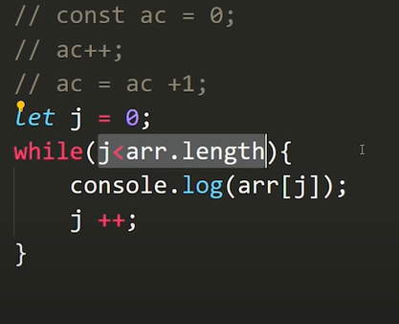

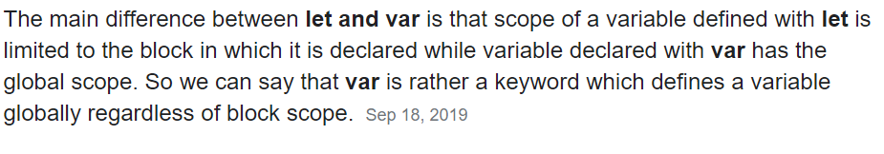

Array Methods:

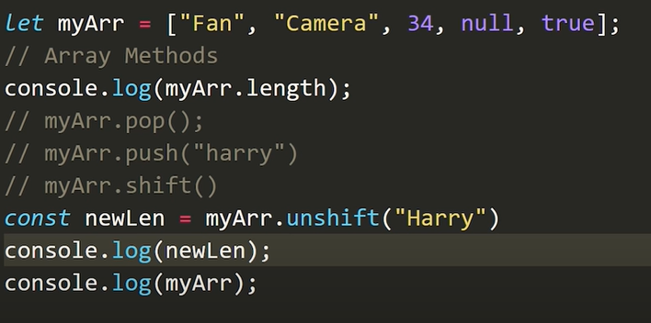

* Myarr.sort();
* Myarr.length;
* Myarr.toString();

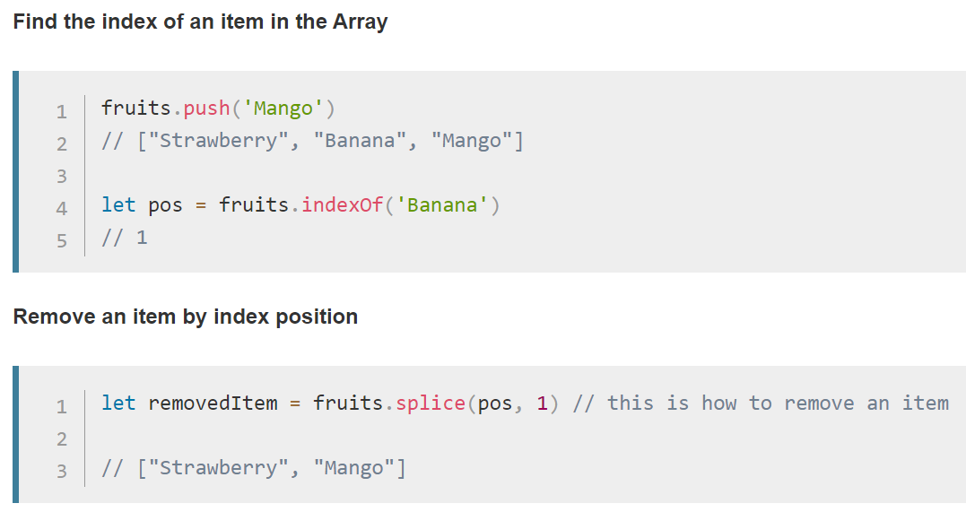

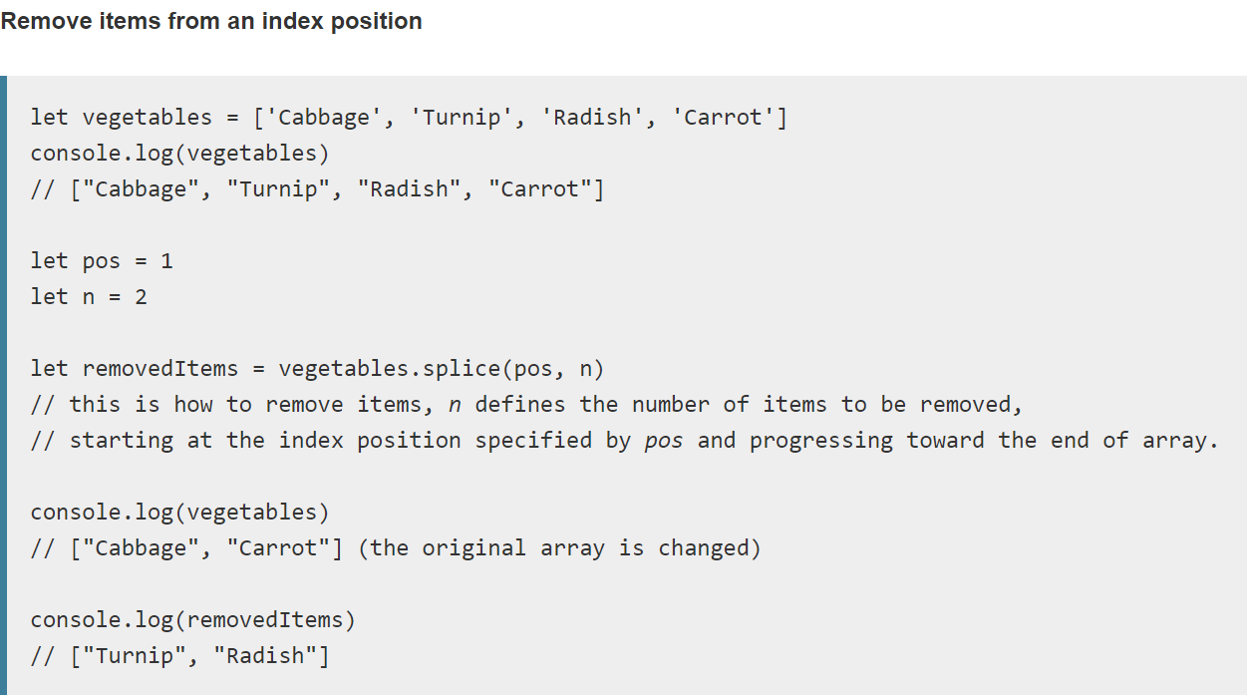

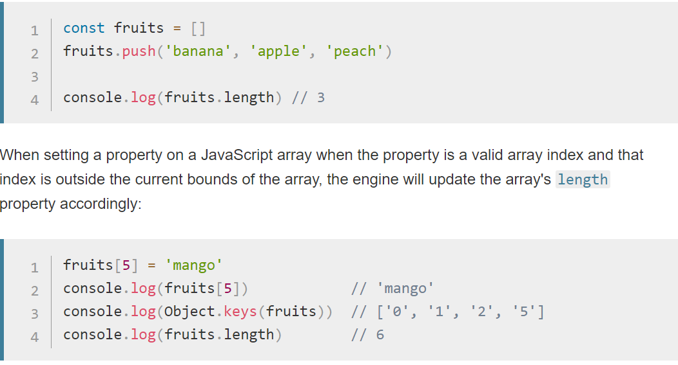

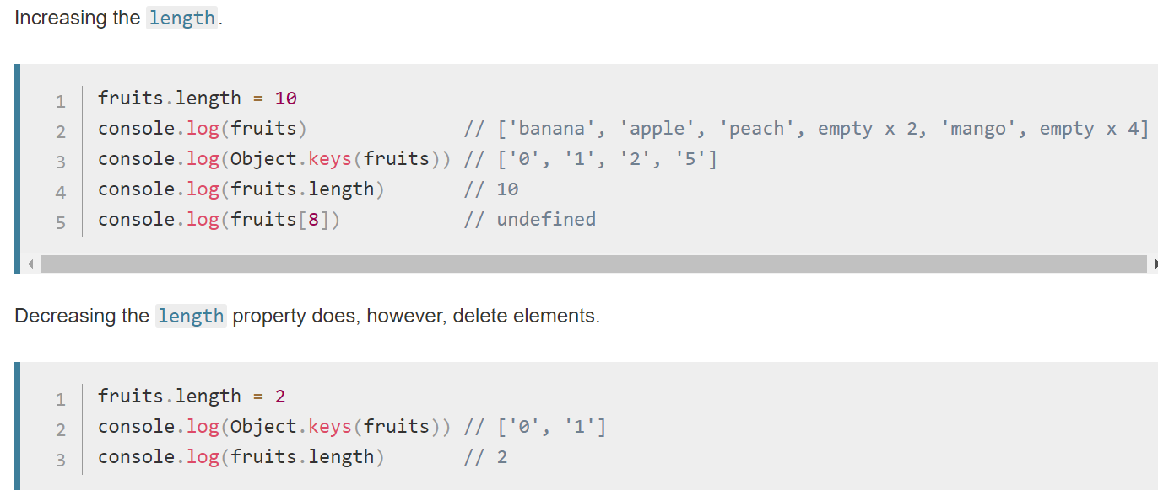

**String Methods in JavaScript:**

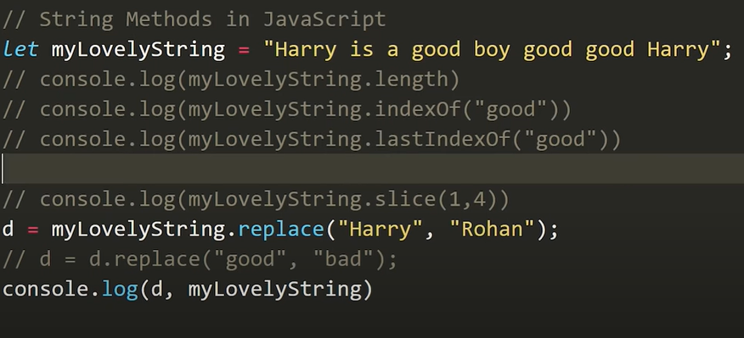

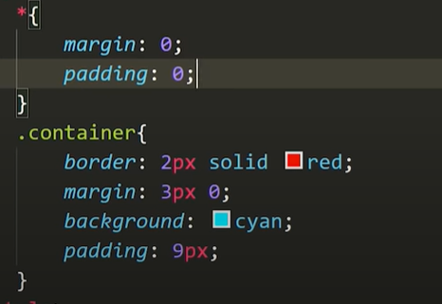

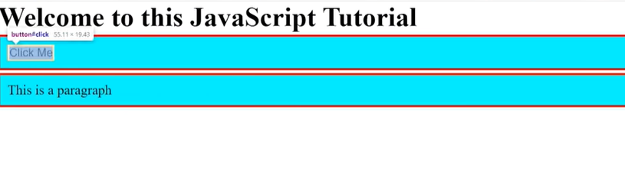

Date:

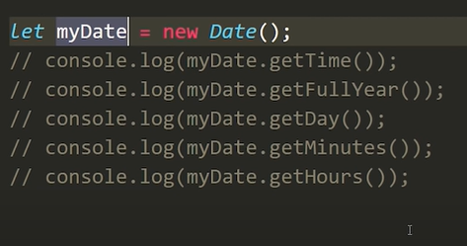

**DOM**

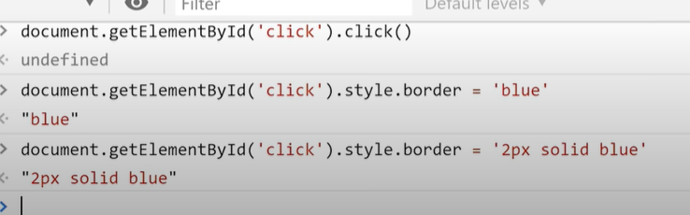

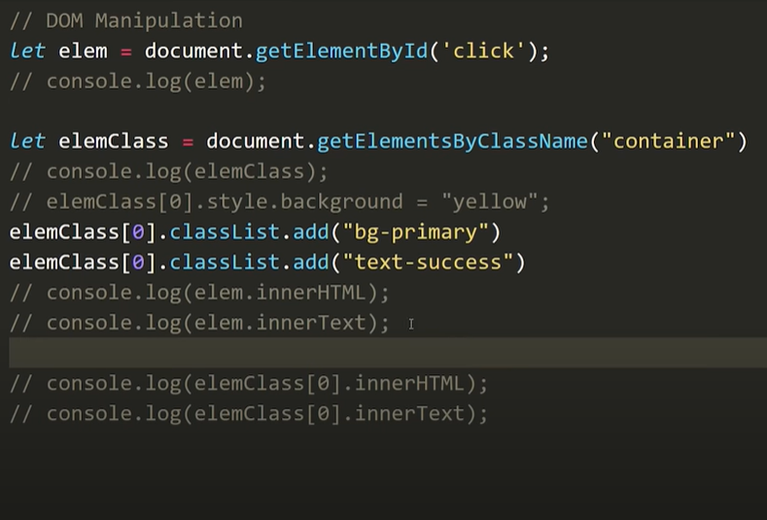

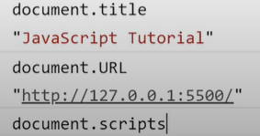

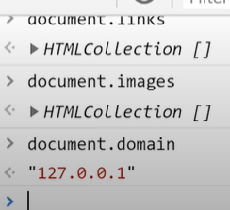

**Select element in the same way css do:**

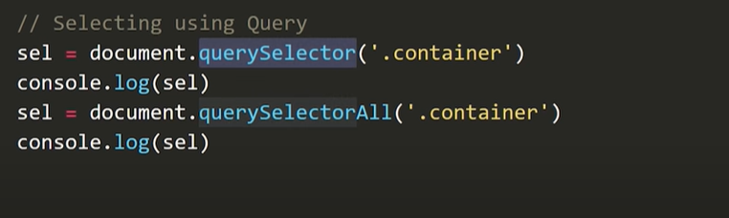

**Events:**



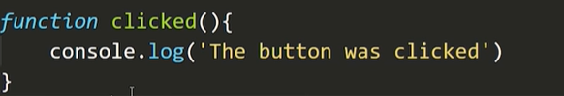

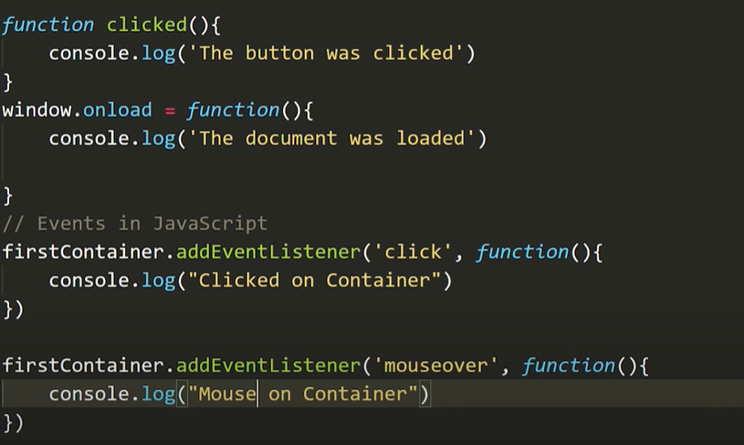

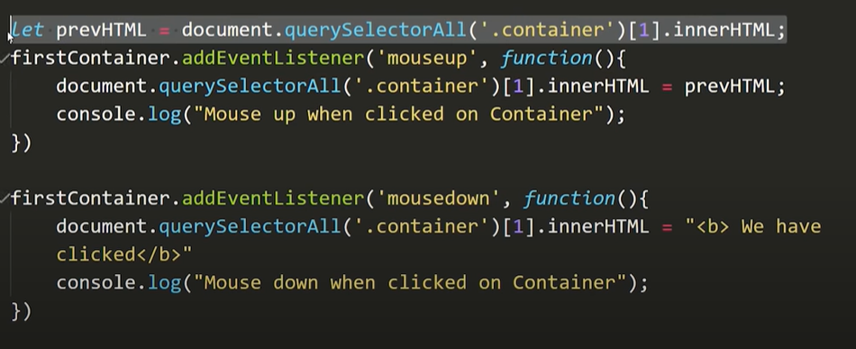

**Set Time out in javascript:**

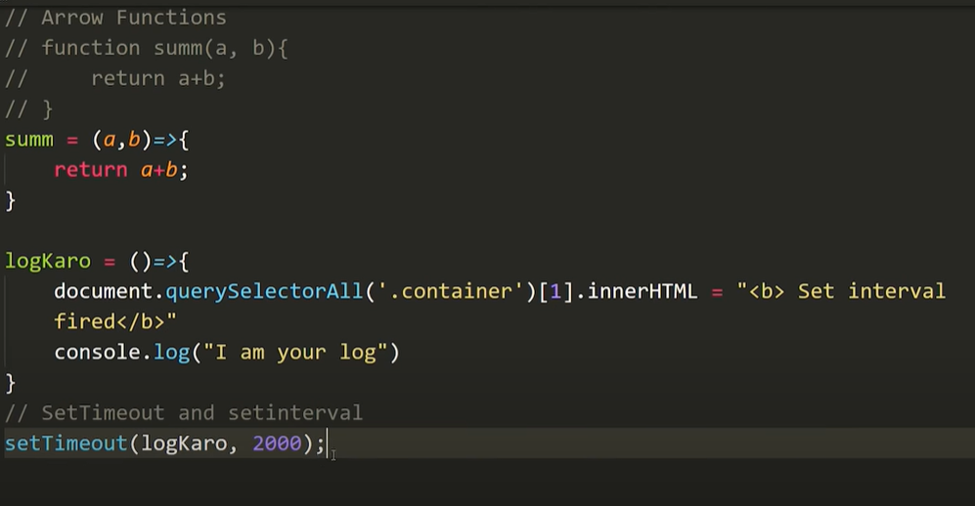

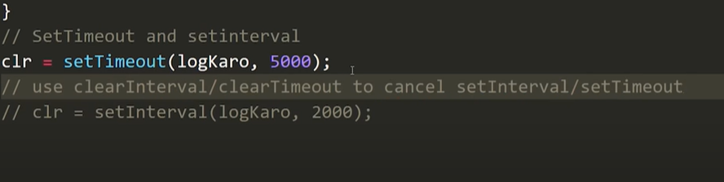

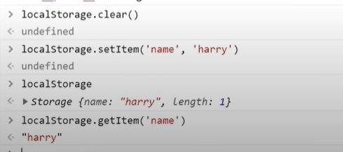

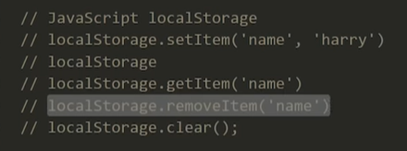

**Json:**

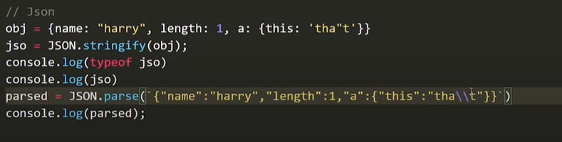

**Project 1: clock**

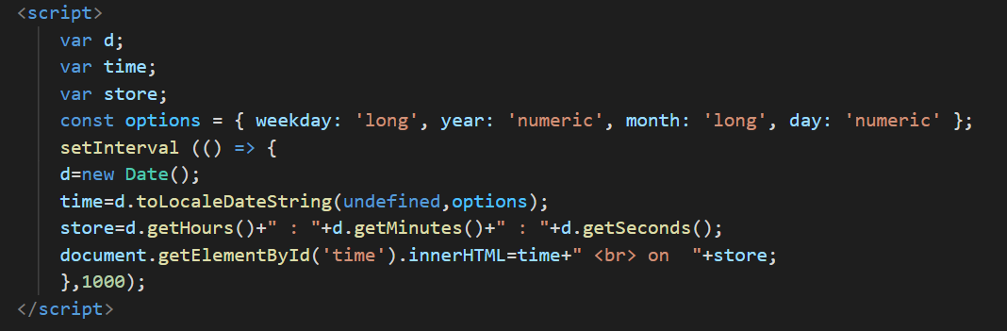

**SetTimeout(function,timeinmilli, para1, para2);**

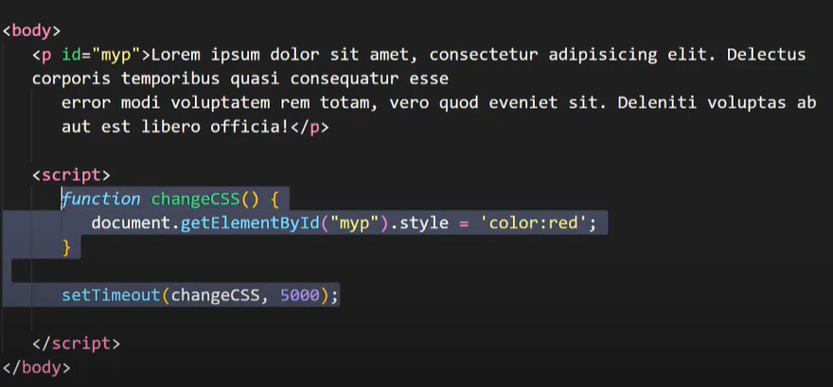

**SetInterval(function, millisec, para1, para2);**

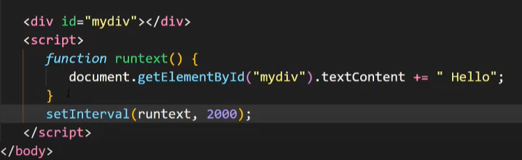

**clearInterval(intervalID);**

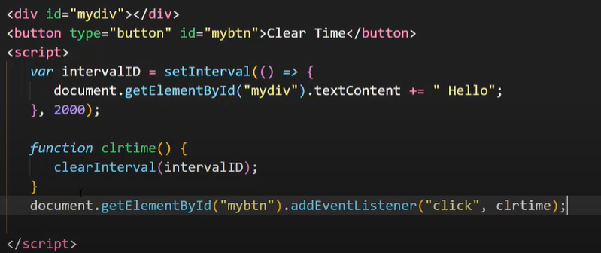

**ClearTimeout(timeoutID);**

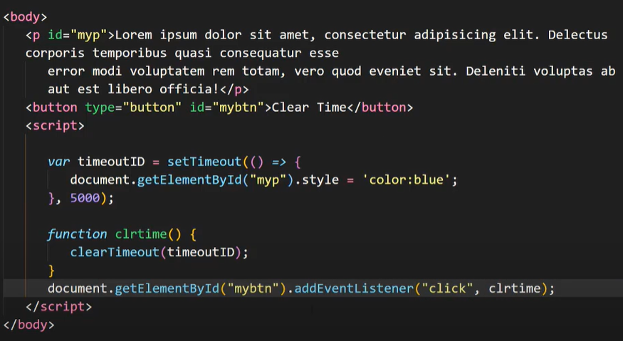

**Project 2:TodoList**

<script>

      function addit(){

        console.log("update.....");

        item=document.getElementById("item").value;

        desc=document.getElementById("desc").value;

           if(localStorage.getItem("itemjson")==null){

             itemjsonArray =[];

             itemjsonArray.push([item,desc]);

             localStorage.setItem("itemjson",JSON.stringify(itemjsonArray));

            }

           else{

            itemjsonStr=localStorage.getItem("itemjson");

             itemjsonArray =JSON.parse([itemjsonStr]);

             itemjsonArray.push([item,desc]);

             localStorage.setItem("itemjson",JSON.stringify(itemjsonArray));

           }

           update();

      }

      function update(){

        if(localStorage.getItem("itemjson")==null){

             itemjsonArray =[];

             localStorage.setItem("itemjson",JSON.stringify(itemjsonArray));

        }

        else{

          itemjsonStr=localStorage.getItem("itemjson");

             itemjsonArray =JSON.parse([itemjsonStr]);

        }

       mytable=document.getElementById("mytable");

       var str="";

       itemjsonArray.forEach((element,index) => {

        str+=` <tr>

        <th scope="row">${index + 1}</th>

        <td>${element[0]}</td>

        <td>${element[1]}</td>

        <td><button type="button" class="btn btn-primary" onclick="deleted(${index})">Delete</button></td>

      </tr> `;

        });

      mytable.innerHTML=str;

     }

      add=document.getElementById("add");

      add.addEventListener("click",addit);

      update();

      function deleted(itemindex){

        console.log("delete",itemindex);

          itemjsonStr=localStorage.getItem("itemjson");

             itemjsonArray =JSON.parse([itemjsonStr]);

             itemjsonArray.splice(itemindex,1);

             localStorage.setItem("itemjson",JSON.stringify(itemjsonArray));

            update();

        }

      function cleared(){

        if(confirm("Do u really want to clear?")){

        localStorage.clear();

        update();

      }

}

    </script>

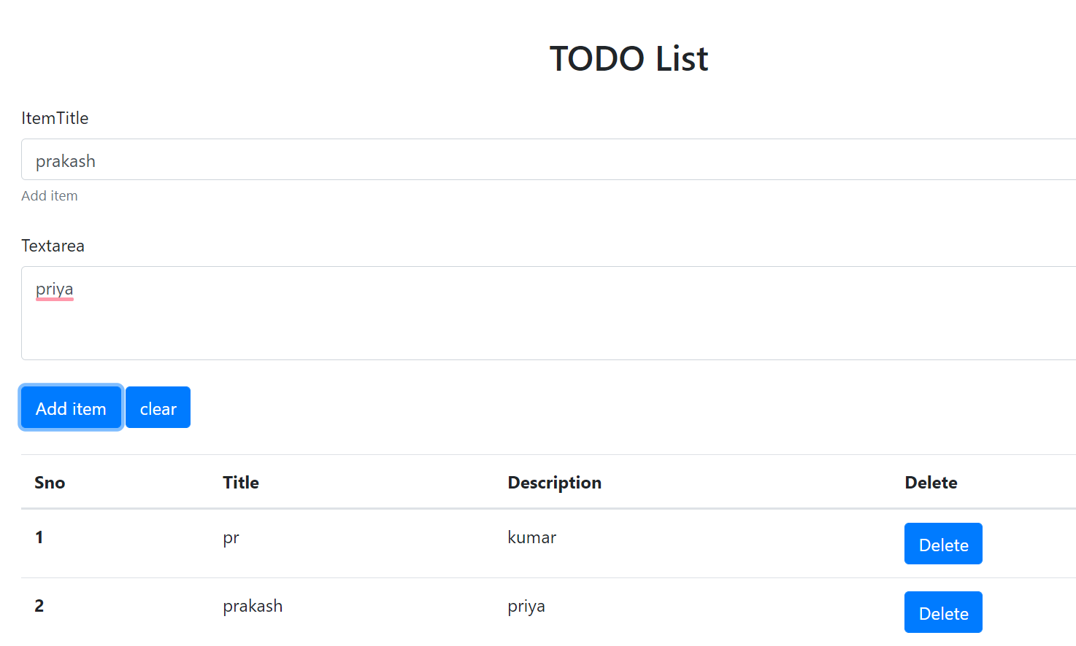

**college calculator**

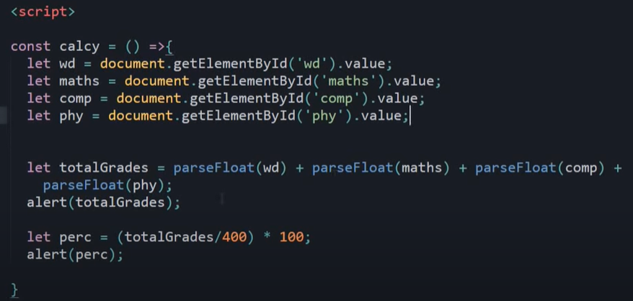

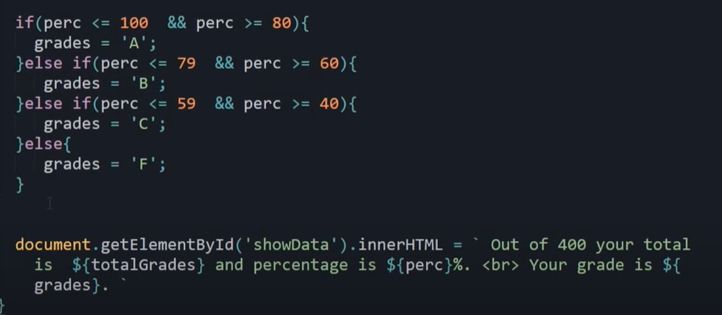

**Project 3: Library book arrangement with types and self**

//

class Book{

constructor(name,author,type){

 this.name=name;

 this.author=author;

 this.type=type;

}

}

class Display{

    added(book){

       let target=document.getElementById('tableBody');

       let str= `<tr>

       <td>${book.name}</td>

       <td>${book.author}</td>

       <td>${book.type}</td>

       </tr> `;

       target.innerHTML+=str;

    }

    cleared(){

       let doc=document.getElementById('libraryForm');

        doc.reset();

    }

    validate(book){

        if(book.name.length<2 || book.author.length<2)

        return false;

        else

        return true;

    }

    show(alert,message){

        let mess=document.getElementById('messaged');

        let boldtext;

        if(alert==='success'){

        boldtext='Success';

        }

        else{

        boldtext='!Error';

        }

        mess.innerHTML= ` <div class="alert alert-${alert} alert-dismissible fade show" role="alert">

                                <strong>${boldtext} : </strong>${message}.

                                <button type="button" class="close" data-dismiss="alert" aria-label="Close">

                                <span aria-hidden="true">&times;</span>

                                </button>

                          </div> `;

        setTimeout(()=>{

           mess.innerHTML='';

        },3000);

    }

}

let libraryForm=document.getElementById('libraryForm');

libraryForm.addEventListener('submit',formsubmit);

function formsubmit(e){

    console.log("helo");

      let name=document.getElementById('bookName').value;

      let author=document.getElementById('author').value;

      let type;

      let fiction=document.getElementById('fiction');

      let programming=document.getElementById('programming');

      let cooking=document.getElementById('cooking');

      if(fiction.checked){

          type=fiction.value;

      }

      else if(programming.checked){

          type=programming.value;

      }

      else if(cooking.checked){

          type=cooking.value;

      }

      let book=new Book(name,author,type);

      console.log("helo1");

      let display=new Display();

      if(display.validate(book)){

          console.log('enter');

        display.added(book);

        display.cleared();

        display.show("success","You book is added to our library succesfully");

                                                                                       }

      else{

          display.show("danger","Please Enter the details before adding");

      }

      e.preventDefault();

}

**Instead of using methods inside class we can use prototype thing:**

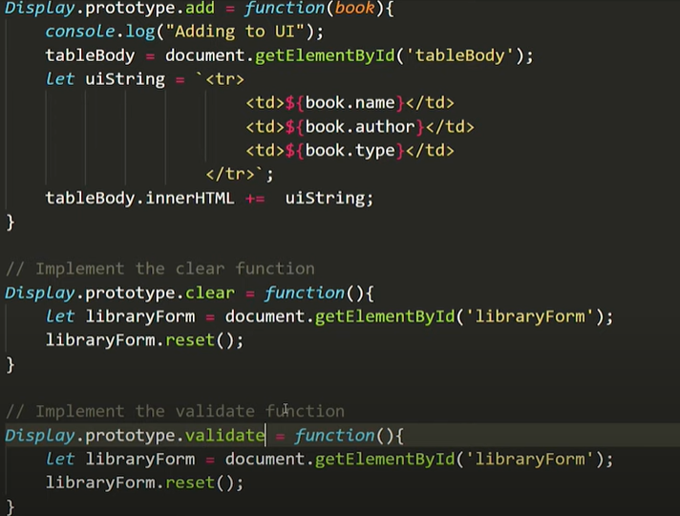

**Project 4: Notes Taking website**

doct = document.getElementById('adbu');

console.log(1);

doct.addEventListener('click', perform);

update();

function perform() {

    console.log(2);

     doc = document.getElementById('ta').value;

    if (localStorage.getItem('note') == null) {

        notearray = [];

        if(validate(doc)){

        notearray.push([doc]);

        show("success","You book is added to our library succesfully");

        }

        else {

        show("danger","Please Enter the details before adding");

        }

        localStorage.setItem('note', JSON.stringify(notearray));

    }

    else {

         items = localStorage.getItem('note');

        notearray = JSON.parse([items]);

        if(validate(doc)){

            notearray.push([doc]);

            show("success","You book is added to our library succesfully");

            }

            else {

                show("danger","Please Enter the details before adding");

            }

        localStorage.setItem('note', JSON.stringify(notearray));

    }

    document.getElementById('ta').value='';//// to reset the value of text area

    update();

}

function update() {

    console.log(3);

     d = document.getElementById('notes');

    if (localStorage.getItem('note') == null) {

        notearray = [];

        localStorage.setItem('note', JSON.stringify(notearray));

    }

    else {

         ite = localStorage.getItem('note');

        notearray = JSON.parse(ite);

    }

    var str="";

    notearray.forEach((element, index) => {

         str+=`<div class=" notecard card my-3 mx-3" style="width: 18rem;">

                    <div class="card-body ">

                    <h5 class="card-title">Note ${index+1}</h5>

                    <p class="card-text">${element}</p>

                    <a href="#" id="${index}"class="btn btn-primary" onclick="deleted(this.id)">Delete</a>

                    </div>

                 </div>`;

    });

    d.innerHTML = str;

}

function deleted(value){

item=localStorage.getItem('note');

notearray=JSON.parse(item);

notearray.splice(value,1);

localStorage.setItem('note',JSON.stringify(notearray));

update();

}

//// search in seach bar

let searchtxt=document.getElementById('searchtxt');

searchtxt.addEventListener("input",searchnow);

function searchnow(){

let inputtxt=searchtxt.value.toLowerCase();

let card=document.getElementsByClassName('notecard');

Array.from(card).forEach(element=>{

let cardtxt=element.getElementsByTagName('p')[0].innerHTML;

if(cardtxt.includes(inputtxt)){

element.style.display="block";

}

else

element.style.display="none";

});

}

function show(alert,message){

    let mess=document.getElementById('messaged');

    let boldtext;

    if(alert==='success'){

    boldtext='Success';

    }

    else{

    boldtext='!Error';

    }

    mess.innerHTML= ` <div class="alert alert-${alert} alert-dismissible fade show" role="alert">

                            <strong>${boldtext} : </strong>${message}.

                            <button type="button" class="close" data-dismiss="alert" aria-label="Close">

                            <span aria-hidden="true">&times;</span>

                            </button>

                      </div> `;

    setTimeout(()=>{

       mess.innerHTML='';

    },3000);

}

function validate(doc){

    if(doc.length<2)

    return false;

    else

    return true; }

* **Transparency in css:**

https://www.youtube.com/watch?v=LmBhZulDm9s&ab_channel=OnlineTutorials